Zumbane lodges
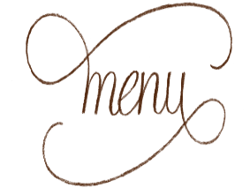
Please note our meals are 2 course and are for 4 or 2 people
(inclusive of one choice of dessert)
1.Zumbane Chicken Masak Merah
Succulent Zimbabwean chicken cooked Malay style with garlic, lemon grass and ginger in a spicy tomato sauce finished with sautéed onion rings. Served with rice.
$ 50-00 for 4 people

2.Thai Chicken coconut curry
This dish which is served with rice noodles, it is the perfect blend of Thai spices with a hint of chilli
$ 30-00 for 2 people

3.Sizzling Beef
Rump seared in olive oil seasoned with soy sauce and crushed black pepper. This comes with rice and a vegetable side dish.
$ 30-00 for 2 people

4. Spaghetti Bolognaise
Totally ZimTalian! Made with prime fat free mince.
$ 60-00 for 4 people

Vegetarian
1. Zumbane Vegetable pasta
Fresh local succulent vegetables in a tomato and herb sauce with basil, garlic and parmesan cheese .
$ 40-00 for 4 people

From the waters-Fish or prawn
2. Trout Nanbanzuke
Pan fried Trout brushed with a soy sauce, rice vinegar and lemon juice mix, served with rice and a vegetable side dish
$ 30-00 for 2 people
$ 60-00 for 4 people

3. Zumbane Garlic Prawns
8 Mozambican tiger prawns grilled in garlic butter served with rice -Being close to Moza has its advantages!
$ 45-00 for 2 people

4. Fish Curry with Roti
Thai fish curry made from Lake Kariba Bream fillets pan fried in a coriander, turmeric, lime leaves, chillies and coconut cream sauce. Served with roti.
$ 60-00 for 4 people
Local Taste – try some traditional Zimbabwean dishes!
1.Nyanga T- bone and Sadza
Wood braaied matured Zimbabwe prime T-bone (350 g) steak done to your liking served with the famous Zimbabwe tomato and onion sauce and a local veg (muriwo) from our garden and a choice of either sadza, rice or salad
$ 60-00 for 4 people

2.Eastern Highlands Oxtail
We first braai it then its 4 hours in the cast iron. Well we cannot really describe the taste. Words fail us!
$ 60-00 for 4 people

Zumbane lodges

Desserts – choose one of the following:-

1. Zumbane Sponge cake with crème fresh
Soft Sponge cake dipped in a syrup infused with Zumbane
Served with local crème fresh

2. Japanese CheeseCake
It's the perfect combination of sponge cake and cheesecake in both taste and texture. It is a scrumptious cake, it's not overly sweet. A real treat for the taste buds
3. Chia seed pudding
Velvety smooth chia seed pudding with a tropical twist! Complemented by a variety of local fruit with swirls of cinnamon and cardamom.
4. Sago pudding
with its comforting sweet custardy texture and delicious gelatinous sago pearls is always a favorite

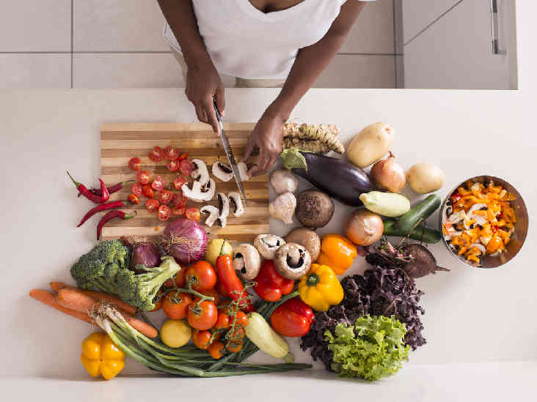

Breakfast

Breakfast for 4 people is US$40.00

Please note all breakfasts are served with either Zumbane tea, Makoni Tea, Tanganda tea or coffee. All breakfasts come with cereals, fruit, yoghurt and freshly squeezed fruit juice

- Full English breakfast-
Pork sausage, bacon, 2 eggs of your choice, grilled tomato and toast

- Baked Berry French toast
Our baked berry French toast is cubed bread dipped in egg topped with berries , it is left overnight and then baked the following morning , served with bacon and grilled tomatoes.

- Sourdough bread mozzarella and Parmesan sandwiches
Our freshly baked sourdough bread with grilled cheese topped with red peppers with a basting of fresh homemade basil pesto.

- Souffle Pancakes with whipped cream and fruit
Freshly made, very light homely pancakes served with scrambled eggs and bacon and our own berry sauce

